Name: ________________________________ Date: ___________________________________

Class: _________________________________ Teacher: ___________________________________

# Math Mini Quiz 7

This Mini Quiz, we’re going to explore the math concepts that you’ve learned so far in this unit. This assignment should take you about **15 minutes**.

1) Below are two different quadratic equations. Solve for x. You may choose the method you’d like to solve it. As a reminder, the quadratic formula can be found to the right.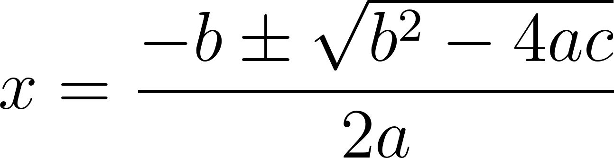

a) 7 = x2 - 13x + 17

b) 0 = x2 - 3x + 7

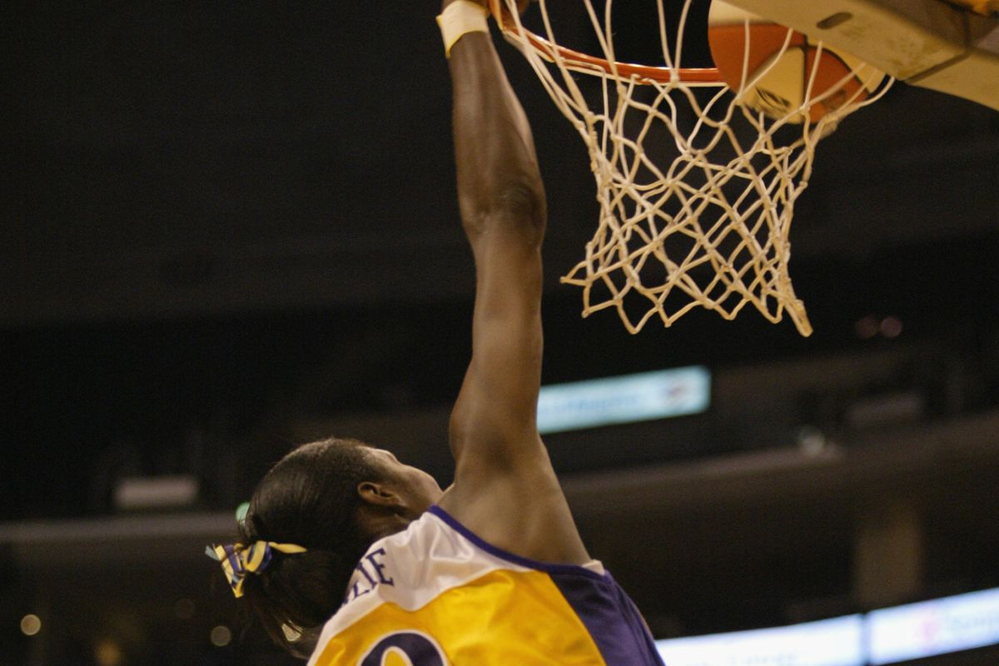2) In 2002, Lisa Leslie became the first woman in the WNBA to dunk[1] during a game. Let’s think about the mechanics of this historic dunk. Let’s assume Leslie’s 2m tall. Let’s call the acceleration of gravity (g) to be 10. We therefore get the *height of the top of her head* during her jump as a function of time to be:

Where is the height of the top of her head in meters and is the time after the start of her jump in seconds. Next let’s assume in order to dunk, the top of her head had to reach the bottom of the net, which stands 2.5 meters above the ground[2].

a) Assume she had been in the air 0.5 seconds when she made the dunk[3]. What was her initial vertical velocity, ? Write the equation for .

b) At what time does she hit the ground again?

c) Lisa actually hits the 2.5m mark twice on her trajectory. Once on the way up and once on the way down. We talked about how one of these times is at 0.5 seconds. When does the other occur? Did she dunk on the way up or or on the way down?

1. Image and information from https://www.swishappeal.com/2015/9/11/9313199/lisa-leslie-dunk-hall-of-fame
2. Estimated from this information: https://www.dimensions.com/element/basketball-rims-nets
3. Based roughly on this calculator: https://www.thehoopsgeek.com/dunk-calculator/